**Lab #1**

**Theory:**

Monte Carlo method is a numerical computational method which consist experimental sampling with random numbers.

let us consider a function f(x) which is positive, hasa lower & upper bound of ‘a’ and ‘b’ respectively is bounded above by a value ‘c’.

if N points are taken in random and n points fall on the curve then

$$\frac{n}{N}=\frac{\int_{a}^{b}{f\left(x\right)dx}}{c(b-a)}$$

As the value of n increases the accuracy increases. And the area of the curve is calculated from above equation.

**Code:**

#include<stdio.h>

#include<conio.h>

#include<stdlib.h>

#include<graphics.h>

#include<dos.h>

void drawcircle();

void main()

{

int gd,gm;

long int n,m,k;

float x,y,ra,pa,ch;

gd=DETECT;

initgraph(&gd,&gm,"c:\\turboc3\\bgi");

drawcircle();

setcolor(RED);

line(200,0,200,200);

line(200,200,400,200);

setcolor(GREEN);

rectangle(200,200,350,50);

printf("enter the N:");

scanf("%ld",&n);

k=n;

m=0;

while(n!=0)

{ x=random(350);

y=random(200);

if(x<=350 && x>200 && y<200 && y>50)

{

ch=(x-200)*(x-200)+(y-200)*(y-200)-150*150;

if(ch<=0)

{

setcolor(BLUE);

circle(x,y,1);

m=m+1;

}

else

{

setcolor(WHITE);

circle(x,y,1);

}

n=n-1;

}

delay(100);

}

printf("\n\n\n\n\n\n\n\n\n\n\n\n\n\n\n");

printf("-----------------------------------------------------------------\n");

printf("|\t\t|\t\t|\t\t|\t\t|\n");

printf("| n \t| N \t|Area of rectgle| Area of curve|\n");

printf("|\t\t|\t\t|\t\t|\t\t|\n");

printf("-----------------------------------------------------------------\n");

printf("|\t\t|\t\t|\t\t|\t\t|\n");

printf("| %ld \t| %ld \t| 22500 \t| %ld \t|\n",m,k,(22500*m)/k);

printf("-----------------------------------------------------------------\n");

getch();

}

void drawcircle()

{

int x,y,p,r;

r=150;

y=r;

x=0;

p=1-r;

while(x<=y)

{

if(p<0)

{

x=x+1;

p=p+2*x+1;

}

else

{

x=x+1;

y=y-1;

p=2*x+p+1-2*y;

}

putpixel(x+200,200-y,RED);

putpixel(200+y,200-x,RED);

}

}

**Output:**

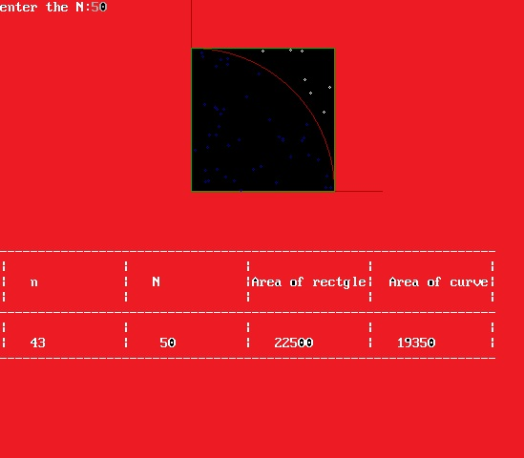

**Conclusion:**

Hence the lab on the Monte Carlo method was performed to calculate the area of the curve.